Structuring your writing

Structure is important when you are writing and speaking to help your reader or listener to follow your line of thinking. It helps to make your points clear and allows your potential employer to make sense of what you are saying.

You need to set the scene and tell the story. The diagram below shows how this might work:

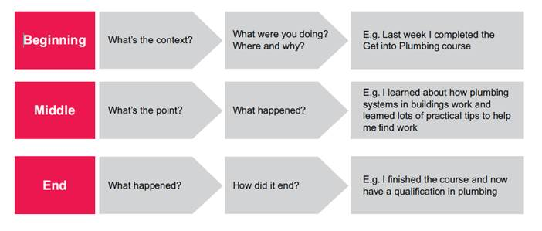

If you use this structure, your potential employer has understood:
- where you were, what you were doing and why
- what happened (what was the point)
- how it ended

Structuring emails
In the last section you practiced writing an email to a potential employer. Here are some more tips about structuring the emails you send.

In general for emails it is a good idea to:
- greet the person you are writing to politely
- say who you are (if it is the first time that you are emailing them)
- say why you are getting in touch
- ask any questions you have (what you want the person to do)
- sign off the email politely

Spelling and grammar
Spelling and grammar are very important to get right. Spelling mistakes and poor grammar can give the impression that you are sloppy and that you don’t really care about what you are doing. Check, double check and triple check! Read your email out loud, use a spellcheck function or as someone else to read it through.

