RESILIENCE
Managing feedback well
Resilience is the capacity to cope well with times of adversity or hardship (and even be strengthened by them). It is the ability to bounce back from difficult times while retaining a positive sense of self.
You’ll need resilience when dealing with your job hunt, and then when you’re at work, to cope with feedback.

- We all learn by making mistakes, and learning how to deal with criticism positively is one way that we can improve our interpersonal relationships with others.
- Most of us don’t like to listen to feedback – it can be an uncomfortable thing to think about, particularly if we think it might be negative. Feedback can be considered as a threat and treated defensively. Can you think of a time when you have done this?

- When we take a step back, we can see that our brains are actually playing a trick on us by responding to feedback negatively, when it should be a chance to learn something.

- We might say we want feedback – but what we really want is to be liked! Critical feedback lets us know that we’re not perfect, which can really hurt our egos.

- We dismiss observations about our behaviour that can help us be more effective in important areas of our work and lives. But keep it in perspective. Without feedback, it’s easy to make the same mistakes over and over again.

- Listen to specific examples you are given. Think of the impact from the behaviour that is being mentioned. Listen to the suggestions about where you can improve. Keep your ego in check and see it as positive.

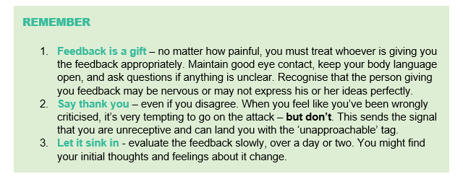

While positive feedback feels good, it’s constructive criticism that helps your personal and professional development. Being receptive to feedback is essential.

