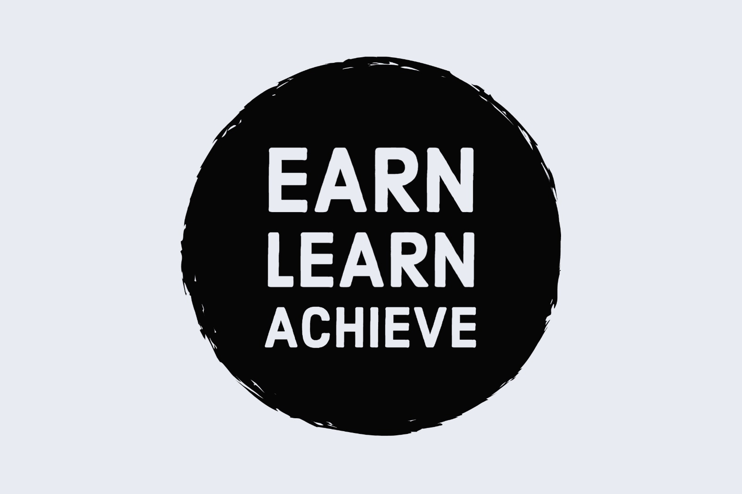

Introduction
National Apprenticeship Week provides a fantastic opportunity to help students to think about their future careers and to raise awareness of the different options available after school, including apprenticeships. We have put together a useful Apprenticeship Activity Pack with 10 different apprenticeship activity ideas for your students, which is available to download here: www.amazingapprenticeships.com/NAW2021
We hope your students enjoy using this pack and we look forward to you sharing your feedback with us.
- The student pack has been designed so that it can be completed individually, or in groups and both in-classroom or remotely.

- This pack for teachers contains the answers that you will need to help your students to mark/score their work.

- Please note that Activity 1, Activity 8 and parts of Activity 10 will capture the students’ thoughts and ideas rather than require specific answers, so answers will not be included in this pack, but may benefit from follow up discussion.
Please note that some of the tasks will require access to a computer and the internet.
 | Hello@amazingapprenticeships.com |  | @AmazingAppsUK |  | @AmazingAppsUK

____________________________________________________________________________
Contents: Activity Sheets
Activity 1: Follow up discussion
Answer sheet 2: Match the apprentice to the job 3
Answer sheet 3: Meet Shaan, an apprentice with AstraZeneca 4
Answer sheet 4: Hear from the Armed Forces about their apprenticeship schemes 6
Answer sheet 5: Understanding apprenticeships 7
Answer sheet 6: Apprenticeship quiz – Which apprenticeship am I? 8
Answer sheet 7: What apprenticeship could I do if I worked at … 10
Activity 8: Follow up discussion
Answer sheet 9: Apprenticeship wordsearch 11
Answer sheet 10: World Skills UK Champions / follow up discussion 11

Answers
____________________________________________________________________________

TASK 2: Match the apprentice to the job
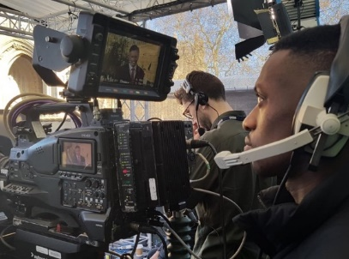
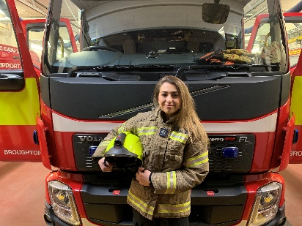

Media Broadcast Camera Operator Firefighter Software Developer
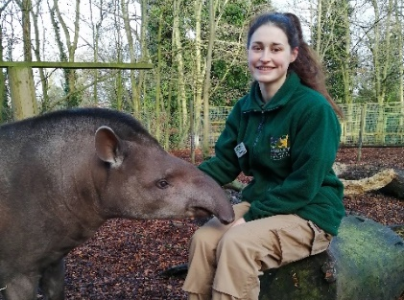
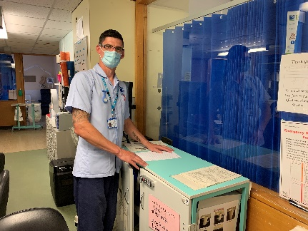
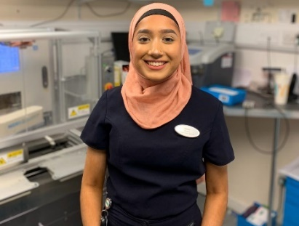
`

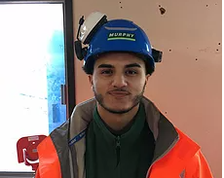
Lab Technician Nurse Zookeeper
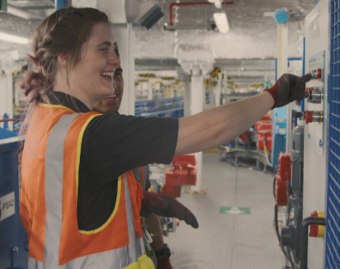

Hairdresser Engineer Project Manager

TASK 3: Meet Shaan, an apprentice with AstraZeneca
Hi, my name is Shaan Gill and I am currently completing a Level 6 degree apprenticeship with AstraZeneca and the University of Kent, which will take 4 years and 9 months to complete.
The end result will be a BSc Bioscience degree and just under 5 years industry work experience. My time is split 20/80 between study and work, 1 day a week is dedicated to studying online via distance learning with the University of Kent and the remaining 4 days working at AstraZeneca.

I am based in the Oncology Translational Medicine department. We carry out biomarker analysis of human tissue and blood samples from real patients enrolled in AstraZeneca clinical trials testing new cancer medicines. The data produced is used to:
- Understand the impact of the medicine on the tumour and microenvironment
- Define dosage levels and schedule
- Identify the right patient populations
- Define the mechanism of resistance
My typical day can be very varied as I tend to work across multiple projects.
If I am in an early stage of a project, I am more office based; doing research, answering emails, having meetings with project leads and making plans or workflows. This is a very interesting part as I get to learn about the scientific rationale behind a project and the medicine.
In the middle of a project, I am heavily lab based. I am in the lab prepping or doing experiments. This is my favourite part of my job as I get to advance my skills, learn a new technique and do practical work.
Towards the end of a project, it is a mixture of office and lab. I am looking at my results, doing quality control and data analysis. If required I may need to repeat an experiment, if samples failed, or to attempt to get better quality results. This part is great as the project comes together and I can see the bigger picture.
I get to see how the work I do and data I produce is beneficial to the project and what conclusions are made from it. Knowing the work I do benefits patients makes every project incredibly rewarding to work on. I’m very appreciative of the opportunity knowing that I can make an impact and difference, even as an apprentice.
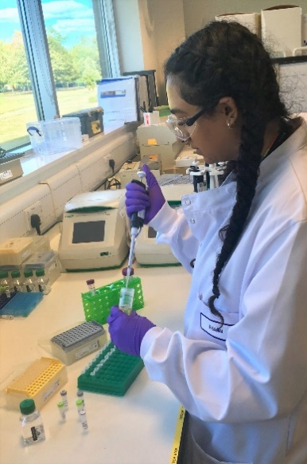
I discovered degree level apprenticeships during a half-term work experience week at GlaxoSmithKline when I was in sixth form.
As soon as I heard about it, it had more appeal to me over university as I was keen to get into the workplace as soon as possible. I researched more degree level apprenticeships in the science industry using the Gov.uk website.
Despite being keen for an apprenticeship I only applied to two; one at GlaxoSmithKline and one at AstraZeneca as both are large pharmaceutical companies with good reputations and within a good distance. Additionally, I still applied to university as the apprenticeships I applied for were competitive so I needed a backup and I wanted to have options.
At the time, I was still undecided which path was better for me and what I would enjoy more. I personally found it rather daunting to give up the conventional and safe route of university for an apprenticeship in which I had to juggle working as well as studying.
The interview process put me at ease once I saw where I would be working, who my potential colleagues would be, and understood more of what my role and course would entail. After the interview I was more set on an apprenticeship being the right path for me.
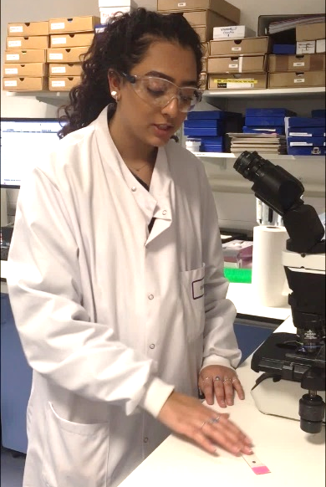
AstraZeneca has a very supportive and inclusive culture, providing a great environment to kickstart my career. I am constantly supported in both my work and studies and provided with personal development opportunities.
Everyone is always willing to take time to answer questions, give advice and share their knowledge. I genuinely feel like everyone wants me to succeed and are always there to help me develop and encourage me to expand my skills.
Studying for a BSc degree whilst working for a world leading pharmaceutical company and contributing to real science is amazing, as well as earning a salary and being debt free!
I found numerous benefits from the apprenticeship programme. The most apparent advantage being the vast amount of hands-on experience gained throughout the programme. At my apprenticeship, I’ve been able to work in a world leading pharmaceutical company contributing to real oncology drug development from the first day!

TASK 4: Hear from the Armed Forces about their apprenticeship schemes

Q1. In which of the films did they note ‘getting to travel’ and the ‘opportunity to do lots of sports’ as benefits of joining as an apprentice?
Answer: Royal Navy
Q2. In the Army film, what task were the four apprentices completing together?
Answer: Checking that the vehicle is serviceable before it goes out on the area
Q3. In the Royal Air Force film, how old could you be to do the Chef apprenticeship?
Answer: 16 - 47
Q4. How long does Phase 1 training take in the Royal Air Force?
Answer: 8 weeks
Q5. What does the first apprentice in the Royal Navy film say is the main benefit of being an apprentice?
Answer: The trust you have in the system
Q6. How was the telecoms apprentice preparing for the exercise the following day in the Army film?
Answer: Putting the radios together so those going out on the exercise tomorrow are prepared
Q7. What were the three example scenarios given of how an apprenticeship could vary day to day in the Royal Navy film?
Answer: 1. One day you could be out on boats
2. Jumping out of helicopters
3. Using various weapon systems
Q8. Do you have to have A Levels to get into a Royal Air Force apprenticeship?
Answer: No
Q9. What was the first apprenticeship job role we heard in the Army film?
Answer: Metal Smith
Q10. How many of the Armed Forces do you think were listed in the ‘Top 100 Apprenticeship Employers 2020’ listing by the National Apprenticeship Service?
Answer: All 3 services

TASK 5: Understanding apprenticeships
1. | Apprenticeships are a real job | True
An apprenticeship is a real job, with a real employer. You will earn a wage, have a contract of employment, have holiday pay and other benefits, just as other employees do.

2. | Apprenticeships are a back-up option to college or University | False
Another myth is that apprenticeships are only for people that do not go on to full-time University or college. That’s not true – there are different levels of apprenticeships suited to everyone, from post-GCSE all the way up to degree level where you will work whilst gaining a degree, making them a Plan A option.

3. | There are opportunities to work your way up the organisation | True
Apprenticeships offer lots of progression opportunities, with many apprentices going on to study at the next or a higher level of apprenticeship, or continuing/starting a new role and working their way up the organisation. Apprentices learn the skills and qualifications required for the job, whilst also learning about their sector and networking with other professionals, which immerses them in the industry and puts them in a good position to kickstart their career.

4. | Apprenticeships are low-skilled | False
Apprenticeships are designed around developing an apprentices’ skill set. Apprentices will learn a wide variety of skills and can go all the way up to a Masters level of study, providing the apprentice with an extensive and high-level skill set.

5. | Apprentices have real responsibilities within their job role | True
There’s a myth that apprenticeships are just like work experience, where you’re given basic tasks or are asked to make the tea, but this isn’t the case. Apprentices contribute to real projects and tasks, which you will see in the different case studies across the activity pack.

6. | Studying for an apprenticeship is easy | False
Some people think that apprenticeships are the easy route, but this is not the case. Apprentices are balancing a full-time job and studying (which can be up to degree level) at the same time. They are learning and adapting in a new working environment and contributing to real-life work projects and tasks, which comes with responsibility, whilst ultimately working towards their end point assessment and achieving their apprenticeship.

7. | Apprenticeships are low paid | False
Many people think that apprentices are low-paid, and this can be true, depending on the employer. Legally, an employer must pay an apprentice the National Minimum Wage for apprentices, which is currently £4.15 per hour. This is lower than the normal National Minimum Wage, but it recognises that some people will be going into their first job with no experience at all. The good news is that lots of employers pay a lot more than the National Minimum Wage for apprentices. Some apprenticeship schemes in big organisations have starting salaries of £15k. Some London based employers will pay even more than this.

8. | Apprenticeships are only with small organisations | False
Hundreds of employers offer apprenticeships, from small local employers to large, international brands that we all know and recognise. Visit www.amazingapprenticeships.com/vacancies to find out more about some of the top large employers who recruit apprentices.
TASK 6: Apprenticeship quiz – Which apprenticeship am I?
Questions | Answers
Q1 | B. Business Administrator
 | Business Administrator is a very popular apprenticeship as so many job roles require an individual to support organisations to run effectively. You can be a business administrator in many different industries and organisations. Business administrator can also lead to job roles such as Data Scientist, Project Manager, Supply chain manager and many more.
Q2 | A.Midwife
Yes, you can be a midwife through an apprenticeship! The midwife apprenticeship is a level 6 degree apprenticeship. meaning that you will achieve a degree at the end of your apprenticeship.
Apprenticeship programmes are always paid for by the employer and/or government, meaning that you will not be expected to pay for any of your training costs, but that you will be paid to work and learn by earning a salary.
Q3 | B. Quantity Surveyor
Quantity Surveyor is a degree apprenticeship. In an organisation, you might not be called the quantity surveyor instead you might have another job title such as Construction Surveyor, Cost Analyst, Commercial Manager but they are all under the same apprenticeship standard.
The Quantity Surveyor apprenticeship is a degree apprenticeship. You will also achieve other qualifications including industry certificates in Site Safety Plus Site Managers’ Safety Training Scheme and Site Environmental Awareness Training Scheme which are required for safe operations in the workplace. On successful completion of your apprenticeship, you will gain Chartered status of RICS (The Royal Institute of Chartered Surveyors) which is highly recognised throughout the world.
Q4 | A. Early Years Educator
 | Yes, you can become an Early Years Educator through an apprenticeship! Early Years Educators, and other job roles such as nursery nurse and childminders, are highly trained professionals who play a key role in ensuring that young children learn and develop well and are kept healthy and safe. They work in a range of settings including full day care, children’s centres, pre-schools, reception classes and as childminders. They typically look after children aged from six weeks to five years.
Q5 | B. Research Scientist
A research scientist is a pretty cool apprenticeship! This occupation can be found in a wide range of industries and organisations. Research scientists are usually responsible for designing, undertaking and analysing information from controlled laboratory-based investigations, experiments and trials.
The Research Scientist is a level 7 apprenticeship, which is equivalent to a master's level. On successful completion, the individual will receive professional recognition through the Royal Society of Biology for Chartered Biologist, the Royal Society of Chemistry for Chartered Chemist or the Institute of Physics for Chartered Physicist.
Q6 | B. Keeper and Aquarist
 | If you are crazy about animals – this is the job for you! The Keeper and Aquarist apprenticeship is a fantastic route into animal care. You will be able to work with a wide range of animals and help to educate others about them. Apprentices are usually employed in zoos, wildlife parks, aquariums, private animal collections, animal reserves, and farms with a zoo licence.
Q7 | C. Physiotherapist
 | This is a great apprenticeship if your passion is helping others. The physiotherapist apprenticeship is a degree apprenticeship, meaning that you will achieve a full degree on successful completion. You will work with people who may present with complex and challenging problems resulting from multiple illnesses, injury or disability. In addition to providing physiotherapy interventions, you will play a substantial educational, health coaching and advisory role to patients, other healthcare professionals and the public. Physiotherapists typically work in a range of large and small organisations across public, private and charitable sectors.
Q8 | A. Air Traffic Controller
 | Yes, you can be an Air Traffic Controller apprentice! These apprentices aren’t just based in a commercial airport. You can be based in military bases, aerodromes or other airfields. The UK manages one of the busiest and most complex pieces of airspace in the world. A range of specialist air traffic controller roles contribute to the safe and efficient movement of aircraft with civil and military operations working collaboratively to maintain a fully integrated service to all users, 24 hours a day, every day of the year.
Q9 | B. Nuclear Welding Inspection Technician
 | Nuclear Welding Inspection Technician is a very important job! As a Nuclear Welding Inspection Technician (NWIT), you will perform a quality control and welding inspection role for the nuclear industry. You will perform inspections on Nuclear sites, operating in a challenging environment where quality standards are paramount and safety is the overriding priority.This apprenticeship usually takes about 4 years to complete and is a level 4 which is a higher apprenticeship.
Q10 | C. Personal Trainer
A Personal Trainer apprenticeship is a great way to keep fit whilst also helping others to improve their fitness and health goals. Personal Trainers are typically employed by a fitness or leisure centre or, once qualified, can be self-employed and should expect to work hours that may include evenings, weekends and public holidays.
On successful completion of this apprenticeship the Personal Trainer will be eligible to apply to become an Affiliate of the Chartered Institute for the Management of Sport and Physical Activity (CIMSPA) and a Member of the Register of Exercise Professionals (REPS).

TASK 7: What apprenticeship could I do if I worked at …
We have listed 10 ideas of apprenticeships that could be linked to the venues below. These examples aim to help your students to think more widely about the range of jobs associated with a venue or sector. However, there are many more examples that could be used.
For a full list of apprenticeships, go to: https://www.instituteforapprenticeships.org/apprenticeship-standards/
You can also visit the Apprenticeship Guide website for ideas on how to link these to sectors, subjects and interests:
http://www.apprenticeshipguide.co.uk/

Music venue | Airport | Stadium
- Live Event Rigger  - Events Assistant  - Chef  - Business Administrator  - Accountancy Professional  - Facilities Manager  - Security First Line Manager  - Cultural Learning & Participation Officer  - Marketing Executive  - Costume Performance Technician | - Pilot  - Cabin crew  - Aerospace Engineer  - Aviation Operations  - HR Consultant  - Travel Consultant  - Project Manager  - Cyber Security Professional  - Air Traffic Controller  - Retail Manager | - Physiotherapist  - Community Sport and Health Officer  - Sporting Excellence Professional  - Sports Turf Operative  - Sales Executive  - Personal Trainer  - Catering Chef  - Community Activator Coach  - Live Event Technician  - Sports Journalist

TASK 9: Apprenticeship wordsearch
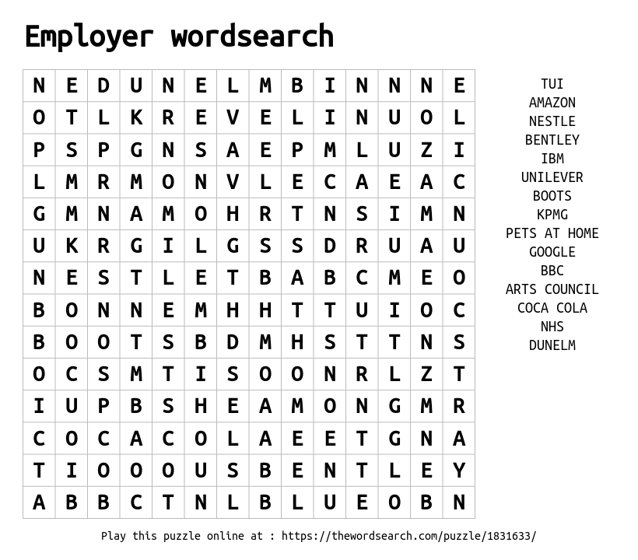

TASK 10: World Skills UK Champions

Every two years an international competition is held between approximately 70 countries. Team UK will compete in up to 37 skill areas in the next international competition.
Every (alternate) two years a European competition is held (EuroSkills) between approximately 45 countries. Team UK will compete in up to 25 skill areas in the next EuroSkills.

Created by:

For more apprenticeship information and free resources, please visit:
www.amazingapprenticeships.com

Get in touch and let us know what you think of this resource:
hello@amazingapprenticeships.com

Find us on social media:
@AmazingAppsUK
@AmazingAppsUK

